|  |
| --- |
|  |
| 新概念 3 册 |
| Lesson28 Five pounds too dear |

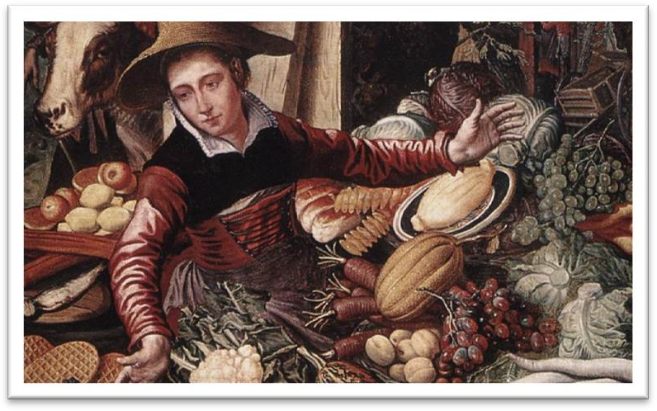

Book

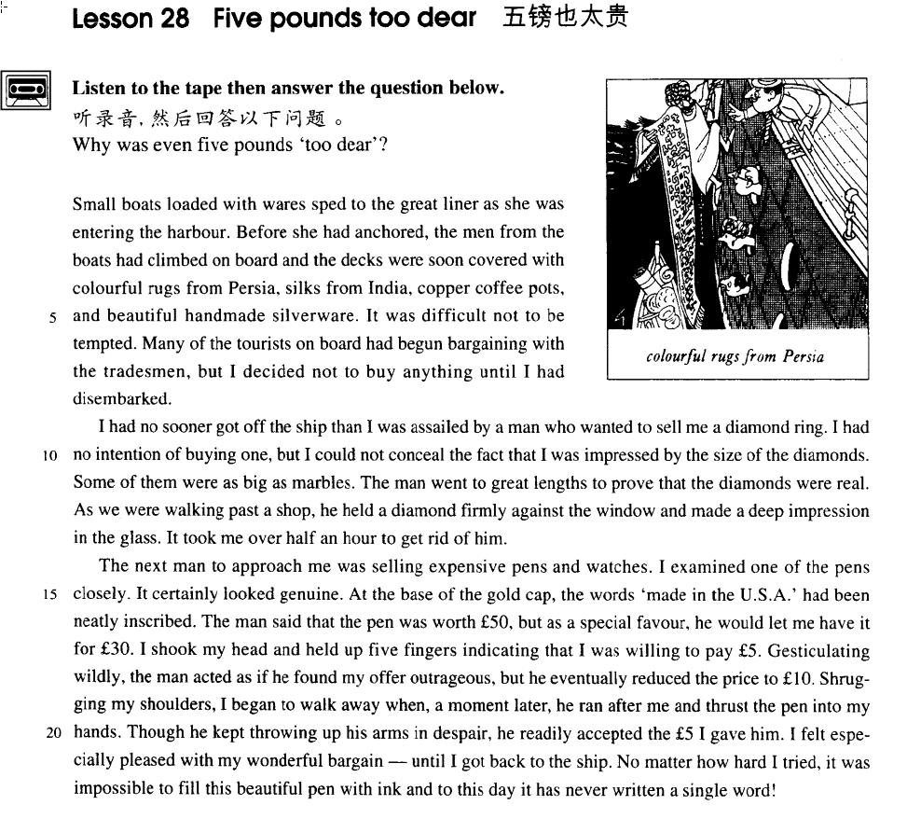

课文

Small boats loaded with wares sped to the great liner as she was entering the harbour.

当一艘大型班船进港的时候，许多小船载着各种杂货快速向客轮驶来。

Before she had anchored, the men from the boats had climbed on board and the decks were soon covered with colourful rugs from Persia, silks from India, copper coffee pots, and beautiful handmade silverware.

大船还未下锚。小船上的人就纷纷爬上客轮。一会儿工夫，甲板上就摆满了色彩斑斓的波斯地毯。印度丝绸。铜咖啡壶以及手工制作的漂亮的银器。

It was difficult not to be tempted.

要想不为这些东西所动心是很困难的。

Many of the tourists on board had begun bargaining with the tradesmen, but I decided not to buy anything until I had disembarked.

船上许多游客开始同商贩讨价还价起来，但我打定主意上岸之前什么也不买。

I had no sooner got off the ship than I was assailed by a man who wanted to sell me a diamond ring.

我刚下船，就被一个人截住，他向我兜售一枚钻石戒指。

I had no intention of buying one, but I could not conceal the fact that I was impressed by the size of the diamonds.

我根本不想买，但我不能掩饰这样一个事实：其钻石之大给我留下了深刻的印象。

Some of them were as big as marbles.

有的钻石像玻璃球那么大。

The man went to great lengths to prove that the diamonds were real.

那人竭力想证明那钻石是真货。

As we were walking past a shop, he held a diamond firmly against the window and made a deep impression in the glass.

我们路过一家商店时，他将一颗钻石使劲地往橱窗上一按，在玻璃上留下一道深痕。

It took me over half an hour to get rid of him.

我花了半个多小时才摆脱了他的纠缠。

The next man to approach me was selling expensive pens and watches.

向我兜售的第二个人是卖名贵钢笔和手表的。

I examined one of the pens closely.

我仔细察看了一枝钢笔，

It certainly looked genuine.

那看上去确实不假，

At the base of the gold cap, the words 'made in the U. S. A.' had been neatly inscribed.

金笔帽下方整齐地刻有“美国制造”字样。

The man said that the pen was worth ￡50, but as a special favour, he would let me have it for ￡30.

那人说那支笔值50英镑，作为特别优惠，他愿意让我出30英镑成交。

I shook my head and held up five fingers indicating that I was willing to pay ￡5.

我摇摇头，伸出5根手指表示我只愿出5镑钱。

Gesticulating wildly, the man acted as if he found my offer outrageous, but he eventually reduced the price to ￡10.

那人激动地打着手势，仿佛我的出价使他不能容忍。但他终于把价钱降到了10英镑。

Shrugging my shoulders I began to walk away when, a moment later, he ran after me and thrust the pen into my hands.

虽然他绝望地举起双手，但他毫不迟疑地收下了我付给他的5镑钱。

Though he kept throwing up his arms in despair, he readily accepted the ￡5 I gave him.

在回到船上之前，我一直为我的绝妙的讨价还价而洋洋得意。

I felt especially pleased with my wonderful bargain -- until I got back to the ship. No matter how hard I tried, it was impossible to fill this beautiful pen with ink and to this day it has never written a single word!

然而不管我如何摆弄，那支漂亮的钢笔就是吸不进墨水来。直到今天，那支笔连一个字也没写过！

词汇讲解

* **wares** [weəz] n. 货物，商品

**ware** n. 某种产品（不可数）

**software** ***n.*** 软件

**hardware *n.*** 计算机硬件；五金器具

**silverware** ***n.*** 银器；镀银餐具

**ironware *n.*** 铁器，金属器具; 铁制品

**chinaware** ***n.*** 陶瓷器

**earthenware *n.*** 陶器；土器

**goods *n.*** 商品；动产；合意的人；真本领

**merchandise *n.*** 商品；货物

* **anchor** ['æŋkə(r)]v. 抛锚
* They **anchored** the ship in the harbor.
* The ship **anchored** in the harbor.

**cast / drop** **anchor** 抛锚

**weigh anchor** / **set sail** 起锚、启航

* **tempt** [tempt]v. 吸引，引诱 【贬义】

**tempt sb. to do sth.** 引诱某人做某事（错事）

**tempt sb. into doing sth.** 【更正式】引诱某人做某事（错事）

* The serpent **tempted** Eve **to** pick the forbidden fruit.
* The serpent **tempted** Eve **into** picking the forbidden fruit.

**lure / seduce / entice sb. into doing sth.** 引诱某人做某事（错事）

* **老友记**
* I guess I set up the video camera to try and **entice** Joey.
* But sadly I could not be **enticed**.
* **bargain** ['bɑ:ɡən] v. 讨价还价

**bargain with sb. over / about sth.** 关于…与某人讨价还价

* He **bargained with** the vendor **over / about** the price of the eggplants.

**haggle with sb. over / about sth.** 【语气更重】关于…与某人讨价还价

* **老友记**
* Oh, this one’s nice! I like this one! Sir? Uh, kind sir? Can I see this one?
* Wait a minute, no, this is, this is the reason you brought me. Okay? I know how to **haggle**. So let me handle this from here on out.

**bargain / buy** ***n.*** 便宜货

* **走遍美国**
* Oh my! Here‘s a real **buy**. It's a **bargain**. This house just came on the market.
* **disembark** [dɪsɪm'bɑ:k] v. 下船，下飞机

**disembark from …** 从…下来

* The passengers **disembarked from** the ferry / plane.

**embark on …**上船/飞机

* We **embarked on** the ship for Shanghai.

**board** 上船/飞机/火车/汽车…

* The couple **boarded** the train for New York.
* Flight No. 714 is now **boarding** at Gate 8.
* **assail** [ə'seɪl] v. 纠缠

**be assailed by / with …** 被某人/某事纠缠

* He **was** **assailed by / with** a street vendor.
* He **was assailed by / with** worries.

**pester** ***vt.*** 纠缠，烦扰；使烦恼 （人缠着人）

**harry** ***vt.*** 折磨；掠夺；骚扰；使苦恼

**harass** ***vt.*** 使困扰；使烦恼；反复袭击

* From the moment he arrived there, he kept on **pestering** his doctor **to** tell him when he would be able to go home.

**sexual harassment** 性骚扰

* **inscribe** [ɪn'skraɪb]v. 刻字；题写

**词根：**“in” + “scribe”(= to write)

* He **inscribed** his name **in** the stone.
* He **inscribed** his name **in** the book.

**describe *v.*** 描述，形容；描绘

**prescribe** ***v.*** 规定；开处方

**proscribe** ***vt.*** 剥夺……的公权；禁止

**subscribe** ***vt.*** 签署；赞成；捐助 ***vi.*** 订阅；捐款；认购；赞成；签署

**transcribe** ***vt.*** 转录；抄写

* **outrageous** [aut'reɪdʒəs] adj. 出人意料的，过分的
* The price is **outrageous**.
* The price is **preposterous**. 荒谬的
* The price is **absurd**. 荒谬的
* That’s **highway robbery / daylight robbery.** （白天抢劫）形容太贵了
* The car costs **a fortune**. 一大笔钱
* The car costs me **an arm and a leg**. 形容太贵了
* **听力真题：**

A．Linda didn't like it.

B．Bill lost it.

C．It was very expensive.

D．It was very small.

* M: Did you see the diamond ring Bill gave to Linda?
* W: I sure did. It must have cost him **an arm and a leg**.
* Q: What does the woman imply about the ring?
* Answer: (C) It was very expensive.

课文讲解

# （题目）

# Five pounds too dear

知识点（1）

**dear**: 昂贵的

**expensive; costly; pricey; steep** 表达昂贵的词汇

知识点（2）

写作：标题中的be动词可省略

* Five pounds too dear
* Italian ex-mayor murdered

# （第一段）

# Small boats loaded with wares sped to the great liner as she was entering the harbour.

**语法分析：**

Small boats loaded with wares（过去分词做后置定语，修饰boats） sped to the great liner *as she was entering the harbour.(时间状语)*

知识点（1）

**语法复习:** 关系代词作主语,其后紧接be动词,作主语的关系词和be动词可同时省略

* Small boats (which were) loaded with wares ……

知识点（2）

**be loaded with …** 满载着…货物

* They quickly **loaded** a small rubber dinghy **with** food, matches, and cans of beer and rowed for a few miles across the Caribbean until they arrived at a tiny coral island.

**be covered with …** 盖满了

**be filled with …** 装满了、某人充满了某种情绪

* … it **is filled with** what looks like a thick, greyish substance. （物品）
* All at once, I noticed that my wife seemed to **be filled with** **alarm**. （情绪）

**be packed / crammed with …** 挤满了

* It has been estimated that if the bridge **were packed with** cars, it would still only be carrying a third of its total capacity.
* The streets **were packed / crammed with** Christmas shoppers.

**be stuffed with …** 填满了

* a pillow **stuffed with** feathers
* duck **stuffed with** ‘eight treasures’
* **stuffed birds** 鸟类标本
* I’m stuffed. = I’m full. 吃饱了

知识点（3）

**speed** 超速

* He was fined for **speeding**.

**speed** 快速移动

* We **sped** down the ski slopes.

知识点（4）

liner ***n.*** 班轮

* The tragic sinking of this great **liner** will always be remembered, for she went down on her first voyage with heavy loss of life.

知识点（5）

**enter the harbor**  入港

**depart from the harbor** 离港

**pull / draw in the station**  （车）进站

**pull / draw out of the station**（车）进（车）进出站

# Before she had anchored, the men from the boats had climbed on board and the decks were soon covered with colourful rugs from Persia, silks from India, copper coffee pots, and beautiful handmade silverware.

**语法分析：**

Before she had anchored（时间状语）, the men *from the boats（后置定语）* had climbed on board and（并列连词） the decks were soon covered with *colourful rugs from Persia*, *silks from India*, *copper coffee pots*, and *beautiful handmade silverware*.

知识点（1）

**课文写法替换：**

* Before she had **anchored**, …
* Before she had **dropped / cast anchor**,

知识点（2）

… **on board = aboard** adv. & prep. 再船上

知识点（3）

* …were soon covered with **colourful**（五颜六色的） rugs from…
* one of the most **colorful** （多姿多彩）figures

知识点（4）

**rug** 小块地毯

**carpet** 满铺地毯

**mat** 垫子

**bathmat** ***n.*** 浴室足垫，垫子

**blanket** （床上）毯子

知识点（5）

**copper** 铜，泛指

**bronze** 青铜

**brass** 黄铜

* the Bronze 青铜器时代
* a brass band 铜管乐队

知识点（6）

**potbelly** ***n.*** 大肚皮

**coffee pot** ***na.*** 咖啡壶；

**teapot *n.*** 茶壶

**flowerpot** ***n.*** 花盆；花钵

kettle ***n.*** 壶；

* the **pot** calling the **kettle** black.

pan ***n.*** 平底锅；

frying pan ***n.*** 长柄平底煎锅

* out of the **frying** pan into the fire.

# It was difficult not to be tempted.

**语法分析：**

It（形式主语） was difficult not to be tempted（真正主语）.

**课文写法替换：**

* It was difficult **to avoid being** tempted.
* No one can **avoid being** influenced by advertisements.
* It was difficult to **resist temptation**.

# Many of the tourists on board had begun bargaining with the tradesmen, but I decided not to buy anything until I had disembarked.

**语法分析：**

Many of the tourists on board(后置定语) had begun bargaining with the tradesmen, but（并列连词） I decided not to buy anything *until I had disembarked(时间状语).*

知识点（1）

**before** 然后

* I shaved **before** I went to the party.
* …, but I decided to disembark **before**(连词) I bought anything.
* …, but I decided to disembark **before**(介词) buying anything.
* 课后题：
* 4．But I decided to disembark ___D___ anything. (11.7-8)

(a) before I would buy (错误分析，时间状语从句中，一般时代替将来时)

(b) until I was buying (错误分析，前面没有否定词，disembark是个不可延续的动词)

(c) until I had bought

(d) before buying

# （第二段）

# I had no sooner got off the ship than I was assailed by a man who wanted to sell me a diamond ring.

**语法分析：**

I had no sooner got off the ship than I was assailed by a man *who wanted to sell me a diamond ring.（定语从句）*

知识点（1）

**no sooner … than …** 刚一…就…

**hardly / barely / scarcely … when / before …**

* **课文写法替换：**
* **No sooner *had***I got off the ship **than** I was assailed … （部分倒装）
* **I *had* hardly** got off the ship **when** I was assailed …
* **Hardly *had*** I got off the ship **when** I was assailed …

知识点（2）

**get off the bus / ship / plane** 下车/船/飞机

* **课文写法替换：**
* I had no sooner **disembarked** from the ship than …

**get on the bus / ship / plane** 上车/船/飞机 （空间**大**的交通工具）

**get into the car / taxi** （空间**小**的交通工具）

**get out of the car / taxi**（空间**小**的交通工具）

知识点（3）

表达**“纠缠”**：

* … than I was **harried / harassed / pestered** by a man who …

# I had no intention of buying one, but I could not conceal the fact that I was impressed by the size of the diamonds.

**语法分析：**

I had no intention of buying one, but（并列句） I could not conceal the fact that I was impressed by the size of the diamonds.

知识点（1）

**have no intention of doing sth.** 无意做某事

**not intend to do sth.** 没打算做某事

* She **intended to dress** up as a ghost and as she had made her costume the night before, she was impatient to try it on.
* I didn’t intend to buy one, …

知识点（2）

表达“对过去发生事情的肯定推测”：

* …, but the man **must have noticed** that I was …
* **课后题：**
* 6 -of buying one, but the man ___A___ that I was impressed ... (1.10)

(a) must have noticed

(b) had to notice 不通顺

(c) must notice 不符合语境

(d) could notice 不能表示对过去的推测

* **课文写法替换：**
* …, but I **could not deny that** I was …
* …, but I **had to admit / acknowledge that** I was …
* **造句**：我当时并没有打算在这家公司工作，但我不能掩饰这样一个事实：他们提供的丰厚的薪水 (handsome salary) 给我留下了深刻的印象。
* I had no intention of working for the company, but I could not conceal the fact that I was impressed by the handsome salary they offered.

# Some of them were as big as marbles.

# The man went to great lengths to prove that the diamonds were real.

知识点（1）

**go to great lengths to do** 竭尽全力做某事

* They have **gone to great lengths to** make us feel welcome.

**do / try one’s best to do** 竭尽全力做某事

* Though the doctor **did his best**, the patient's recovery was slow.

**do / try one’s utmost to do** 竭尽全力做某事

* You play to win, and the game has little meaning unless you **do your utmost to win**.

**do everything / all one can to do** 竭尽全力做某事

* **课后题：**Lesson29
* 9.Though the doctor ___D___... (1.15)

(a) worked very well

(b) could not have been better

(c) was extremely skilled

(d) **did all he could** 竭尽全力

**give one’s all to do** 竭尽全力

**spare no effort to do** 不遗余力

**go all out to do** 竭尽全力

* **听力真题：**

A．They should wait for John to bring the dessert.

B．He thinks John must have spent a lot of money for the dinner.

C．The dessert also looks impressive.

D．He helped John make the sandwiches.

* W: Look at the delicious sandwiches. John’s really **gone all out** this time.
* M: Just wait until you see the dessert.

Q: What does the man imply?

Answer: (C) The dessert also looks impressive.

知识点（2）

**real** 真货

It certainly looked **genuine**.（真货）

# As we were walking past a shop, he held a diamond firmly against the window and made a deep impression in the glass.

知识点（1）

**impression** ***n.*** 印象；效果，影响；压痕，印记；

* made a deep **impression**(印痕) in the glass.
* …… and it gave me the **impression**（印象） that it was about to leap out at me.

**have / get the impression that …** 觉得…

**be under the impression that ...** 误以为…

* Though the crew **were** at first **under the impression that** the lost ship had been found, the contents of the chest proved them wrong.

知识点（2）

**in** the glass 玻璃上，介词in

* He hit me **on** the nose.
* He hit me **in** the face.
* If you are lucky enough to get a sleeper, you spend half the night staring at the small blue light **in** the ceiling, …

# I took over half an hour to get rid of him.

知识点（1）

**take** 花时间

* The journalist immediately set out to obtain these important facts, but he took a long time to send them. （人做主语）
* I **spent** （只能人做主语）over half an hour (in) getting rid of him.

知识点（2）

**get rid of sb.** 打发走某人

**dispose of sb.** 打发走某人

* There is no quicker method of **disposing of patients** than by giving them what they are asking for, …

**expel** 开除

* He was **expelled** from school for bad behavior.

# （第三段）

# The next man to approach me was selling expensive pens and watches.

知识点（1）

**语法：**the first, the second, the next, the last, the best, the only … 后常跟不定式作定语

* The next man ***to approach me*** was selling expensive pens and watches.
* When he landed near Dover, the first person ***to greet him***was a local policeman.
* The only other ship ***to match her*** was the Thermopylae.
* The first of the two ships ***to reach Java***after the race had begun was the Thermopylae, but on the Indian Ocean, the Cutty Sark took the lead.
* The last creature ***to compete with man***was the mosquito.

知识点（2）

**approach** 接近，（可以表示位置距离，也可表示时间）

* My birthday is fast **approaching**.
* My birthday is **coming soon**.
* My birthday is **near at hand**.
* My birthday is **just around the corner**.

# I examined one of the pens closely.

**closely** = **carefully** 非常仔细的

* … advertisers have made a **close** study of human nature…

# It certainly looked genuine.

genuine 真货

# At the base of the gold cap, the words 'made in the U. S. A.' had been neatly inscribed.

知识点（1）

**at the base of …** 在…底部

**on the basis of …**在…的基础上

* Decisions were often made **on the basis of** false information.

知识点（2）

**gold**（像金的）

* gold ring / medal

**golden** (金色的)

* golden sunshine / hair
* Speech is silver, but silence is **golden**.

知识点（3）

**neatly** 工整的

* His handwriting is **neat**.
* He has a teacher’s handwriting.
* His handwriting is **illegible**. （潦草的）
* He has a doctor’s handwriting.

知识点（4）

**inscribe** 只能表达刻字

**engrave** 雕刻花纹…

* Historians have long been puzzled by dots, lines and symbols which have been **engraved** on walls, bones, and the ivory tusks of mammoths.

# The man said that the pen was worth ￡50, but as a special favour, he would let me have it for ￡30.

**语法分析：**

The man said that（后面整个句子做宾语从句） the pen was worth £50, but（宾语从句内部的并列） as a special favour（介词短语做状语）, he would let me have it for £30.

# I shook my head and held up five fingers indicating that I was willing to pay ￡5.

**语法分析：**

I shook my head and held up five fingers indicating（非谓语） that（indicating的宾语） I was willing to pay £5.

知识点（1）

I **shook my head** … （习语）不同意

I **disagreed** …

I **said no to** him …

知识点（2）

**hold up** = **extend** 伸出

知识点（3）

**indicate** = **signify**（间接地）表明、表示

* Her tone **indicated** that she didn’t believe a word of my explanation.
* She **signified** her agreement by nodding her head.
* **课文写法替换：**
* … held up five fingers **signifying** that I was …

# Gesticulating wildly, the man acted as if he found my offer outrageous, but he eventually reduced the price to ￡10.

**语法分析：**

Gesticulating wildly（非谓语）, the man acted *as if he found my offer outrageous(方式状语),* but（并列句） he eventually reduced the price to £10.

知识点（1）

**gesticulate** 打手势

知识点（2）

outrageous ***adj.*** 粗暴的；可恶的；令人吃惊的

absurd ***adj.*** 荒谬的；可笑的

preposterous ***adj.*** 荒谬的；可笑的

* **课后题：**
* 11．The man acted as if he found my offer ______ (1.18)

(a) irritating ***adj.*** 刺激的；气人的；使愤怒的

(b) preposterous ***adj.*** 荒谬的；可笑的

(c) hilarious ***adj.*** 欢闹的；非常滑稽的；喜不自禁的

(d) unspeakable ***adj.*** 无法形容的；不能以言语表达的；坏透了的

知识点（3）

**eventually**

**at last**

**finally**

**in the end** 只能句首和句尾

# Shrugging my shoulders I began to walk away when, a moment later, he ran after me and thrust the pen into my hands.

**语法分析：**

*Shrugging my shoulders(非谓语，做伴随状语),* I began to walk away *when（引导时间状语，做“然后”）,* ***a moment later****（插入语）, he ran after me and thrust the pen into my hands.*

知识点（1）

**shrug one’s shoulders** 耸肩 （1.不感兴趣，2.不知道，3.怀疑不相信）

**with a shrug** 耸肩（做伴随状语）

知识点（2）

**when** 然后

* I will be on vacation till the end of the month **when** I return to shanghai.

知识点（3）

**run after** = **chase** 追

* Just as it was leaving, Mr. Taylor rushed out and **ran after** it throwing ashtrays and vases, …

# Though he kept throwing up his arms in despair, he readily accepted the ￡5 I gave him.

知识点（1）

**readily** = **willingly** 乐意的

* There are times when we would **willingly** give everything we possess to save our lives, …

# I felt especially pleased with my wonderful bargain -- until I got back to the ship.

# No matter how hard I tried, it was impossible to fill this beautiful pen with ink and to this day it has never written a single word!

**语法分析：**

*No matter how hard I tried（让步状语从句）*, it（形式主语） was impossible ***to（真正主语） fill this beautiful pen with ink***and（并列连词） *to this day* it has never written a single word!

知识点（1）

**No matter how …** = **However hard I tried, …**

* Judges, **however** wise or eminent, are human and can make mistakes.

Imagine their dismay when they found a beautifully-cooked wallet and notes turned to ash.

知识点（2）

**to this day** = **so far** 迄今为止（用于完成时）

知识点（3）

**a single** 加强语气

* I spent the whole day in my room, but I did not write **a single** card!
* He earned enormous sums of money and was paid as much as ￡100 for **a single** appearance.
* They had **a single** aim, **a solitary** goal—the top!
* **造句**：无论我多么好地喂养 (feed) 这只鸡，它就是不肯产卵 (breed)，直到今天它连一个蛋也没下过。
* No matter how well I fed her, it was impossible to persuade the beautiful hen to breed and to this day she has never laid a single egg!